SAVEETHA SCHOOL OF ENGINEERING, SIMATS
Department of Computer Science and Engineering
MOBILE COMPUTING
Course Code: ITA03-MP
ASSIGNMENT 3 – CO3
Wireless Networks, Mobile IP and Routing Protocols | Pair Work | 50 Marks
Submitted by
Team Member | Register Number | Role in the Pair
Pramith M | 192372174 | Student A
Sai Preethika N | 192372344 | Student B

Faculty In-charge
Dr. Suresh Bala
November 2026

Simulation Set-up and Assumptions
The assignment asks both students to run a small simulation or worked example for Q1, Q2, Q5 and Q7. All results in this report come from two simple Python models written for this assignment (NumPy and SciPy). They are not NS-2 or NS-3 traces, so the numbers show trends and relative behaviour, not exact real-world values. Every figure and table that uses simulated data is marked as such.
Table 1: Models used in this report
Model | Used in | Main parameters
WLAN handoff model | Q1 | 3 access points at 0, 200 and 400 m; coverage radius 120 m (40 m overlap).  User moves back and forth along the 400 m corridor for 300 s; 20 packets/s sent to a server.  Handoff when another AP is at least 10 m closer (hysteresis); each handoff interrupts the link for 250 ms.  Loss and delay grow towards the cell edge. 5 runs per speed, averaged.
Routing model (DSDV vs AODV) | Q5, Q6, Q7 | N nodes in a 1000 m × 1000 m area, radio range 250 m, random-waypoint mobility at speed v.  8 constant-rate flows (or N/2 for small N); 150 s simulated at 0.5 s steps; 5 random seeds averaged.  DSDV: full table broadcast every 15 s by every node, triggered updates when a node's table changes, route tables lag the real topology by 1 s.  AODV: RREQ flood + RREP on demand, RERR on a link break, HELLO once per second from nodes on active routes.  1% loss per hop; per-hop delay 10 ms, increased slightly by control traffic.
Analytical calculations | Q2, Q4, Q7 | Wireless hop 10 ms, FA to HA one-way 40 ms (microwave backhaul), HA processing 10 ms, Layer-2 handoff 50 ms, agent discovery 20 ms.  IP-in-IP tunnel header 20 bytes; IP+UDP header 40 bytes.

Limitations (important for viva): the routing model has no MAC-layer collisions, no RREQ rate-limiting or expanding-ring search for AODV, and no route time-outs. When the network is partitioned (small N) AODV repeats failed floods, which inflates its overhead. Results should be explained as model behaviour, not as measured performance of real hardware.

Q1 – Wireless Network Architecture and Mobility Analysis

Part A – Introduction to Wireless Networks

Shared group work (Pramith and Preethika)
A wireless network connects devices through radio signals instead of cables. A mobile user can keep communicating while moving, but the radio channel is shared, slower and less reliable than a wired link. The main characteristics are:
- Shared broadcast medium: all nodes in a cell share one channel, so capacity is divided among active users.
- Limited bandwidth: effective WLAN throughput is roughly 25 Mbps even for a 54 Mbps nominal rate, far below wired Ethernet.
- Higher error rate: fading, interference and obstacles cause frame loss and retransmissions.
- Mobility: the point of attachment changes as the user moves, so handoff is needed.
- Limited battery and weaker security: mobile devices are power-constrained and the open medium can be overheard.
Components identified for our architecture: mobile nodes (laptop, phone, tablet), wireless access points that define cells, wireless links, a wired distribution system (router/switch), the core network, and an application server. Constraints: limited bandwidth per cell, connectivity that weakens near the cell edge, and mobility that forces handoff between cells.
Simulated scenario: a mobile user sends 20 packets/s to an application server while moving back and forth across three access points (Table 1). The communication flow was tested as follows:
- The mobile node associates with the nearest access point and sends a frame over the shared wireless channel.
- The access point forwards the frame over the wired link to the router.
- The router sends the packet through the core network to the application server; the reply returns along the reverse path.
- As the user approaches the cell edge, signal quality drops and delay rises.
- In the overlap region the node scans, authenticates and re-associates with the next access point (250 ms); traffic then resumes through the new AP.
Result of the test: with a stationary user the average one-way delay was 23.0 ms with 1.0% packet loss. This is the baseline against which mobility is compared.

Student A – Pramith M: Network architecture analysis
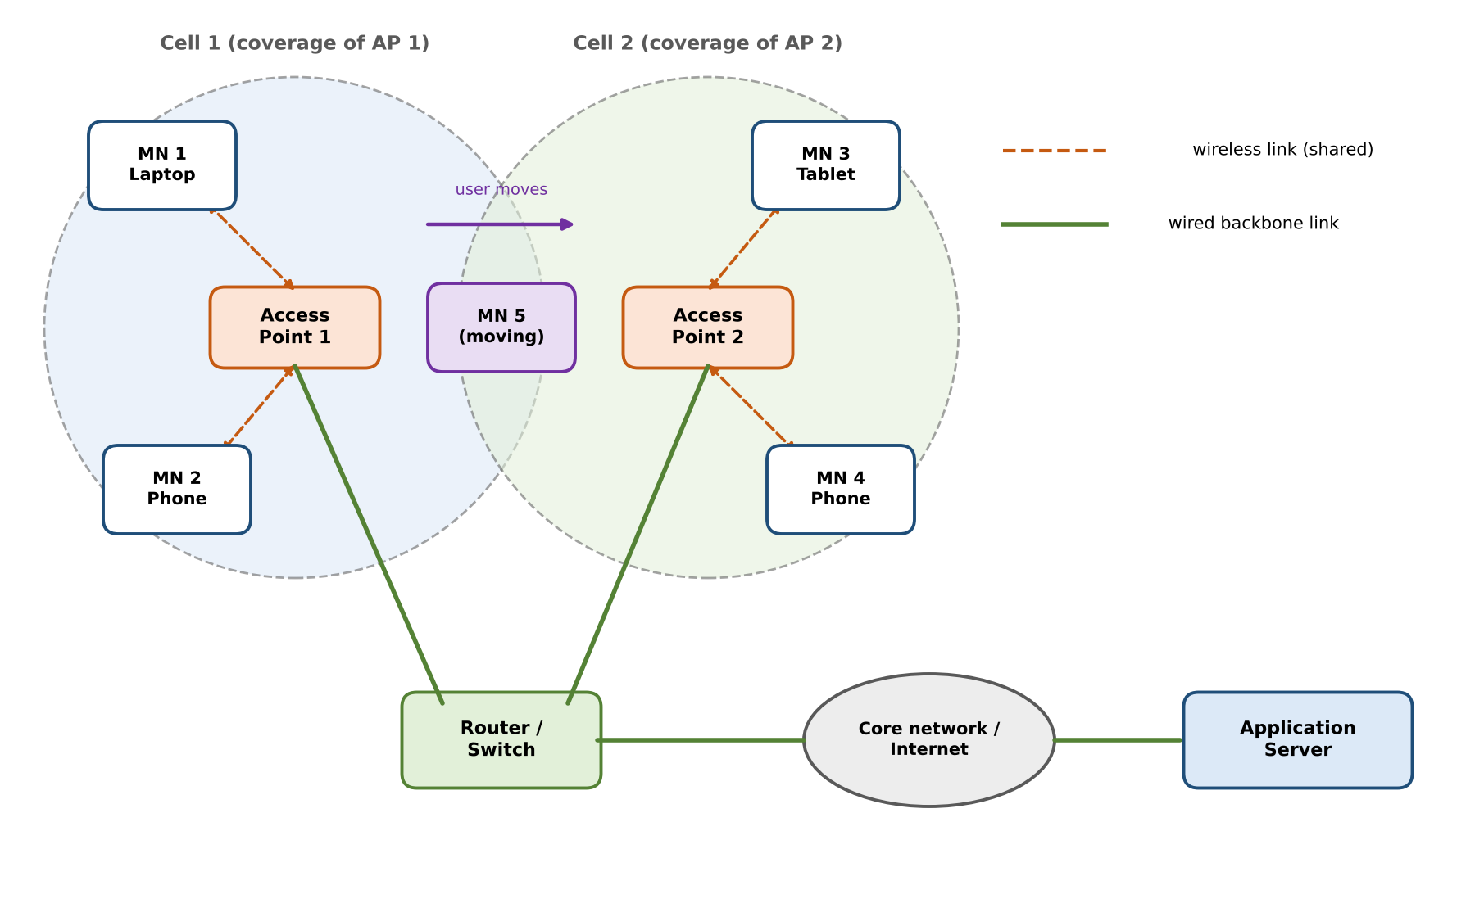
Figure 1: Wireless network architecture with two access points, a moving node and the wired backbone
Table 2: Major components and their roles
Component | Role in the network
Mobile Node (MN) | End-user device that sends and receives data over a radio link and changes its point of attachment as the user moves.
Access Point (AP) / Base Station | Creates a coverage cell, controls access to the shared channel and bridges wireless frames to the wired network.
Wireless link | Shared radio channel between MN and AP; limited bandwidth, variable quality.
Router / Switch (distribution system) | Connects the APs together and to the core network; forwards packets between cells and the Internet.
Core network / Internet | Carries traffic between the access network and remote hosts.
Application Server | The communication end-point that the mobile users talk to.

Table 3: Wireless communication characteristics
Characteristic | Effect on communication
Shared medium (CSMA/CA) | Only one node transmits at a time in a cell; contention causes back-off delay and collisions.
Limited bandwidth | Per-user throughput falls as users are added (Table 4).
Signal attenuation | Quality falls with distance; edge-of-cell users get lower data rates and more retransmissions.
Interference / noise | Increases bit errors and frame loss.
Mobility | Users cross cell boundaries and need handoff; ongoing sessions may be interrupted.

Table 4: Effect of limited bandwidth (assumed 25 Mbps effective cell capacity, equal sharing)
Active users in one cell | Throughput per user (Mbps) | Observation
1 | 25.0 | Full effective capacity (about 25 Mbps).
5 | 5.0 | Enough for video calls.
10 | 2.5 | Streaming quality starts to suffer.
20 | 1.25 | Only light traffic is comfortable.
10 at cell edge (rate falls to ≈ 6 Mbps) | ≈ 0.3 | Both low signal and sharing reduce throughput.

How mobile nodes communicate through the infrastructure: a mobile node never talks directly to the server. Every packet goes MN → AP (wireless) → router (wired) → core network → server. Because the AP is the only way in, losing the AP link (out of range or AP failure) means losing connectivity, which is why overlapping coverage is used.

Student B – Preethika N: Mobility and performance analysis
Five representative mobility scenarios were simulated for the same corridor and traffic (Table 5).
Table 5: Mobility scenarios (simulation results, average of 5 runs)
Scenario | Speed (m/s) | Handoffs per min | Total packet loss (%) | Loss during handoff (%) | Avg delay (ms)
Stationary | 0 | 0.0 | 1.0 | 0.0 | 23.0
Walking | 1.5 | 0.4 | 1.9 | 0.2 | 28.2
Cycling | 5 | 1.4 | 2.4 | 0.6 | 28.7
Car (urban) | 15 | 4.4 | 3.5 | 1.8 | 28.5
Fast vehicle | 30 | 9.0 | 5.4 | 3.8 | 28.3

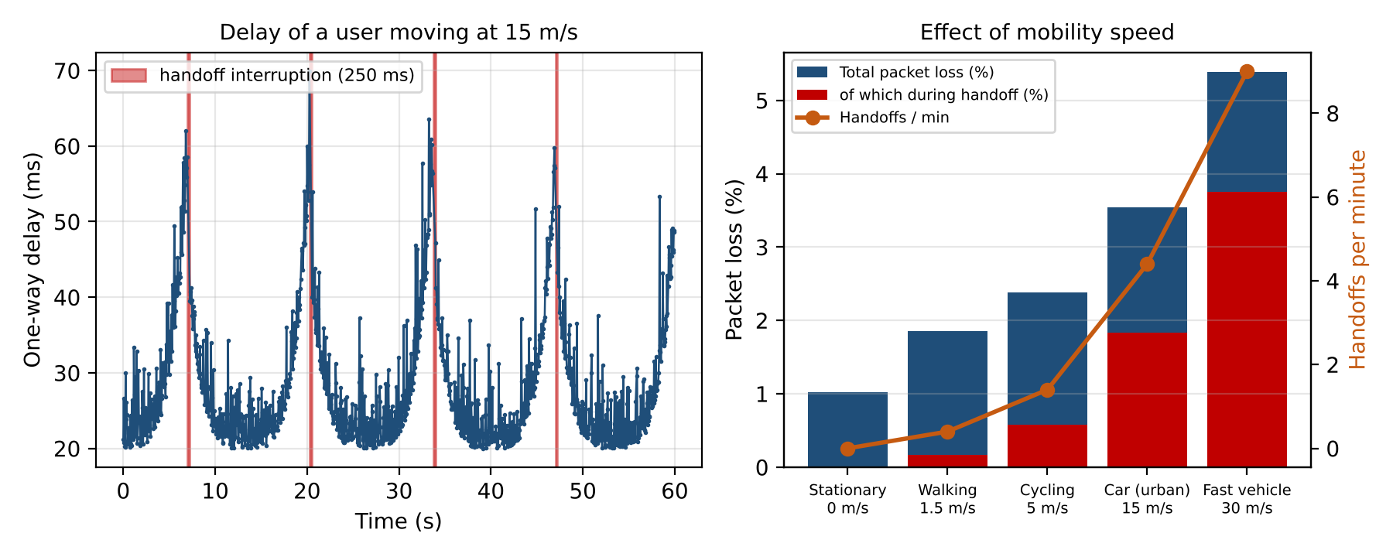
Figure 2: Left: delay over time for a user at 15 m/s (red = handoff interruptions). Right: packet loss and handoff rate versus speed
Handoff and connectivity interruption. A handoff consists of scanning for a better AP, authentication and re-association, which we modelled as 250 ms. All packets sent in that window are lost, so each handoff costs about 5 packets at 20 packets/s. The red bands in Figure 2 show these gaps.
Packet loss and delay. Loss has two sources: (1) handoff interruption, which grows in proportion to speed because handoffs become more frequent, and (2) weaker signal near the cell edge. Total loss rises from 1.0% for a stationary user to 5.4% at 30 m/s, and 3.8 percentage points of that come from handoffs. Average delay rises from 23.0 ms to about 29 ms as soon as the user moves, because the user spends time near the cell edge where retransmissions are needed.
Effect of changing network conditions:
- More users in the cell: channel sharing reduces throughput and increases queueing delay (Table 4).
- Weaker signal or interference: rate adaptation lowers the data rate and retransmissions increase delay.
- Overlap size: a larger overlap allows an earlier, more reliable handoff; a small overlap risks a coverage gap.
- AP failure: users in that cell lose connectivity until they re-associate with a neighbouring AP.
Comparison across mobility conditions: the stationary and walking users see almost no disruption (0.4 handoff/min). A cyclist has 1.4 handoffs/min, a car 4.4 and a fast vehicle 9.0. Real-time services such as voice are therefore tolerable for pedestrians but need faster handoff for vehicles.

Part B – Wireless Mobility Scenario

Shared group work (Pramith and Preethika)
A mobile user moves along a corridor covered by three overlapping access points (Figure 3). The user sends a constant stream of packets to the server while moving from the first cell to the last.
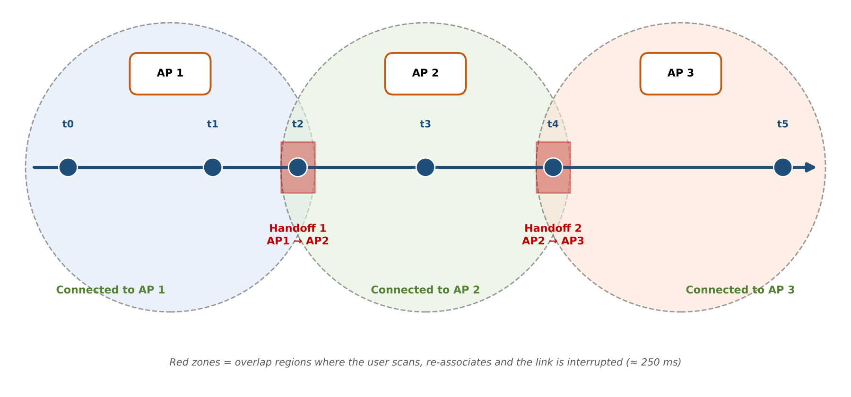
Figure 3: Mobile user moving between three wireless coverage areas with two handoffs

Student A – Pramith M: Analytical investigation
Table 6: Successful and interrupted communication
Case | Definition used in this scenario
Successful communication | The node is associated with an AP, signal is above the threshold and the packet reaches the server with delay below 100 ms.
Interrupted communication | Packets sent while the node is scanning / re-associating (250 ms window), or while it is outside any coverage area.

Table 7: Sequence of mobility events
Time | Mobility event | Effect on communication
t0 | Node connected to AP 1, close to the AP. | Low delay (≈ 20–25 ms), about 1% loss.
t1 | Node moves towards the edge of cell 1. | Signal weakens; delay rises towards ≈ 55 ms and loss rises to ≈ 5%.
t2 | Node enters the overlap; AP 2 is 10 m closer than AP 1. | Handoff triggered: scan, authenticate, re-associate (250 ms). Interrupted.
t2 + 0.25 s | Association with AP 2 complete. | Traffic resumes through AP 2 with low delay.
t3 | Node near the centre of cell 2. | Normal communication.
t4 | Second overlap region reached. | Handoff to AP 3; another 250 ms interruption.
t5 | Node in cell 3. | Normal communication; scenario ends at the end of the corridor.

Table 8: Analytical evidence compared with simulation (two handoffs per 400 m traverse, 0.25 s each)
Speed (m/s) | Handoffs/min (analytical = 0.3 × v) | Handoffs/min (simulated) | Interrupted time (analytical %) | Interrupted time (simulated %)
1.5 | 0.4 | 0.4 | 0.2 | 0.2
5 | 1.5 | 1.4 | 0.6 | 0.6
15 | 4.5 | 4.4 | 1.9 | 1.8
30 | 9.0 | 9.0 | 3.8 | 3.8

Increasing mobility. Handoffs per minute grow linearly with speed (two handoffs per 400 m, so 0.3 × v per minute). The analytical estimate matches the simulation closely, which supports the model. Delay and delivery therefore degrade steadily: at 30 m/s about 3.8% of packets are lost purely because of handoffs.

Student B – Preethika N: Mobility logic
Mobility decision sequence (used in the simulation):
- Measure the distance (signal strength) to the serving AP and to the nearest AP at every time step.
- If a neighbouring AP is at least 10 m closer (hysteresis), start a handoff; otherwise stay with the current AP. Hysteresis prevents ping-pong handoffs near the boundary.
- During the handoff (250 ms) all packets are dropped; the serving AP is changed to the new one.
- After the handoff, communication continues; repeat from step 1 until the scenario ends.
When the point of attachment changes: only when the new AP is clearly better than the current one and no handoff is already in progress. Conditions affected: delay (spike before handoff), packet delivery (loss during handoff), throughput (rate drops at the edge), and any ongoing session (it must continue through the new AP). Termination condition: the scenario completes when the node reaches the end of the corridor (x = 400 m); in the repeated experiment the node turns around and the run ends after 300 s.
Repeated mobility and efficiency. Define communication efficiency as 100 − loss. It falls from 99.0% (stationary) to 94.6% (30 m/s). At 30 m/s there are 9.0 handoffs per minute, about 45 lost packets per minute from handoffs alone, so frequent mobility directly reduces efficiency.

Q2 – Mobile IP and Mobility Management

Shared group work (Pramith and Preethika)
A normal IP address identifies both a host and its network. When a node moves to a different network, its address no longer matches the network it is in, so existing connections break. Mobile IP solves this by letting the node keep a permanent home address while it also uses a temporary care-of address (CoA) in the visited network. A home agent keeps the mapping between the two and forwards packets.
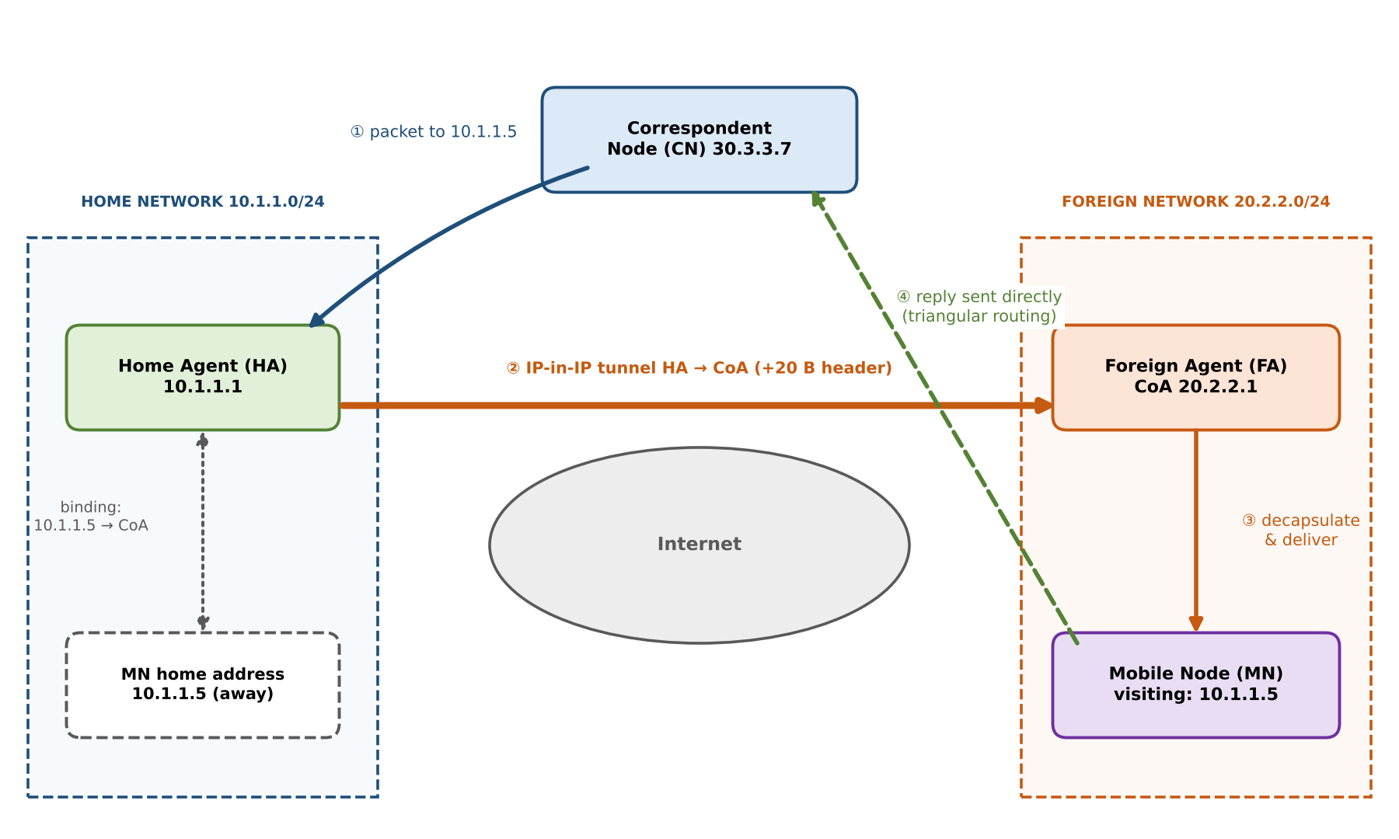
Figure 4: Mobile IP architecture: MN, Home Agent, Foreign Agent and Correspondent Node
Table 9: Addresses used in the worked example
Entity | Address in our worked example
Mobile Node (MN) | Home address 10.1.1.5 (home network 10.1.1.0/24)
Home Agent (HA) | 10.1.1.1
Foreign Agent (FA) | 20.2.2.1 – used as the care-of address (foreign-agent CoA)
Correspondent Node (CN) | 30.3.3.7

Agent discovery. Home and foreign agents periodically broadcast agent advertisements (ICMP router advertisements with a mobility extension). The mobile node can also send an agent solicitation. From the advertisement the node learns whether it is at home or in a foreign network and obtains the CoA.
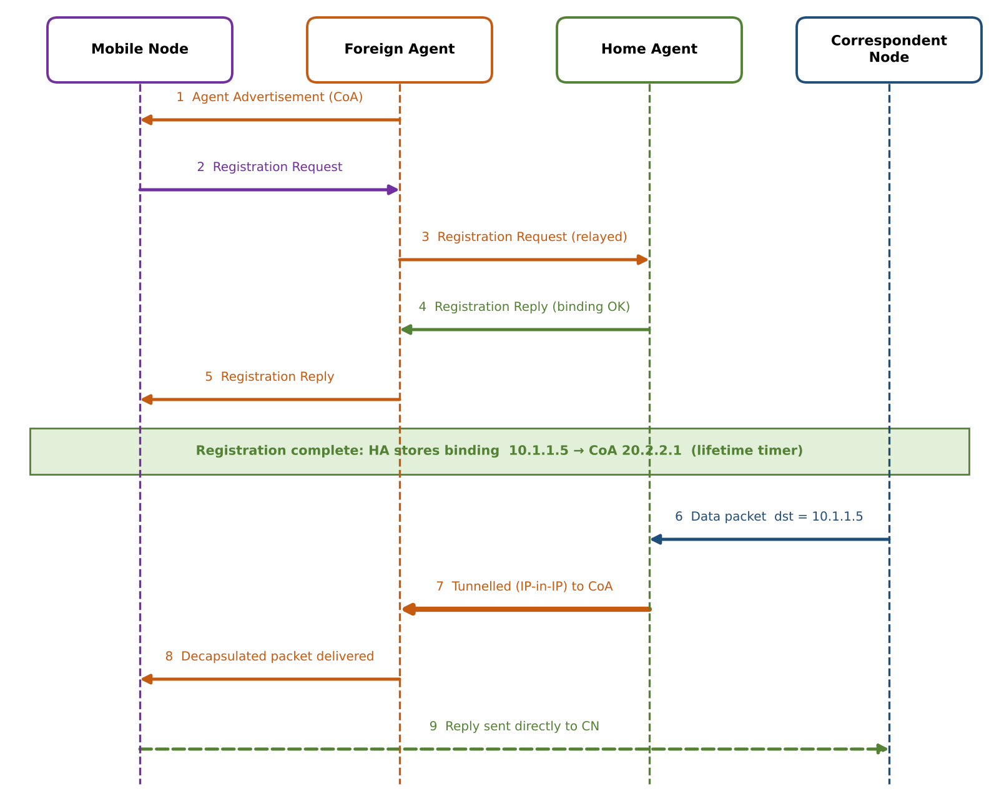
Figure 5: Registration and packet-flow sequence in Mobile IP
Worked example (follows Figure 5).
- MN moves from 10.1.1.0/24 to 20.2.2.0/24 and hears an advertisement from FA 20.2.2.1, so it learns that it is away from home and gets CoA = 20.2.2.1.
- MN sends a Registration Request to the FA; the FA relays it to the HA (10.1.1.1).
- HA records the binding 10.1.1.5 → 20.2.2.1 with a lifetime (for example 300 s) and returns a Registration Reply through the FA.
- CN (30.3.3.7) sends a packet with destination 10.1.1.5. It is routed to the home network, where the HA intercepts it (proxy ARP).
- HA encapsulates it: outer header source 10.1.1.1, destination 20.2.2.1, protocol 4 (IP-in-IP), inner packet unchanged.
- FA removes the outer header and delivers the inner packet to MN over the local link.
- MN replies with source 10.1.1.5 and destination 30.3.3.7 directly through the FA; the CN never needs to know that MN moved.

Student A – Pramith M: Mobile IP operation
Table 10: Roles in Mobile IP
Entity | Role
Mobile Node | Keeps its permanent home address, detects movement from agent advertisements, obtains a CoA, registers with the HA and keeps using its home address for all sessions.
Home Agent | Router on the home network. Stores the binding (home address → CoA), intercepts packets for the absent MN, encapsulates and tunnels them to the CoA, and authenticates registrations.
Foreign Agent | Router on the visited network. Advertises its CoA, relays registration messages, decapsulates tunnelled packets and delivers them to the MN.
Correspondent Node | Any host communicating with the MN. It sends packets to the MN's home address and needs no Mobile IP support in basic Mobile IP.

Registration and location updating. Every time the MN attaches to a new network it repeats registration. The binding at the HA is the "location information": it is updated on each registration and expires if not renewed, so the HA always knows the current CoA. When the MN returns home it deregisters.
Packet delivery and tunnelling. Packets to the MN travel CN → home network → HA → tunnel → FA → MN (Figure 4, steps 1 to 3). IP-in-IP encapsulation adds a 20-byte outer header. Replies travel MN → FA → CN directly (step 4), which creates the triangular path.

Student B – Preethika N: Mobile IP challenge analysis
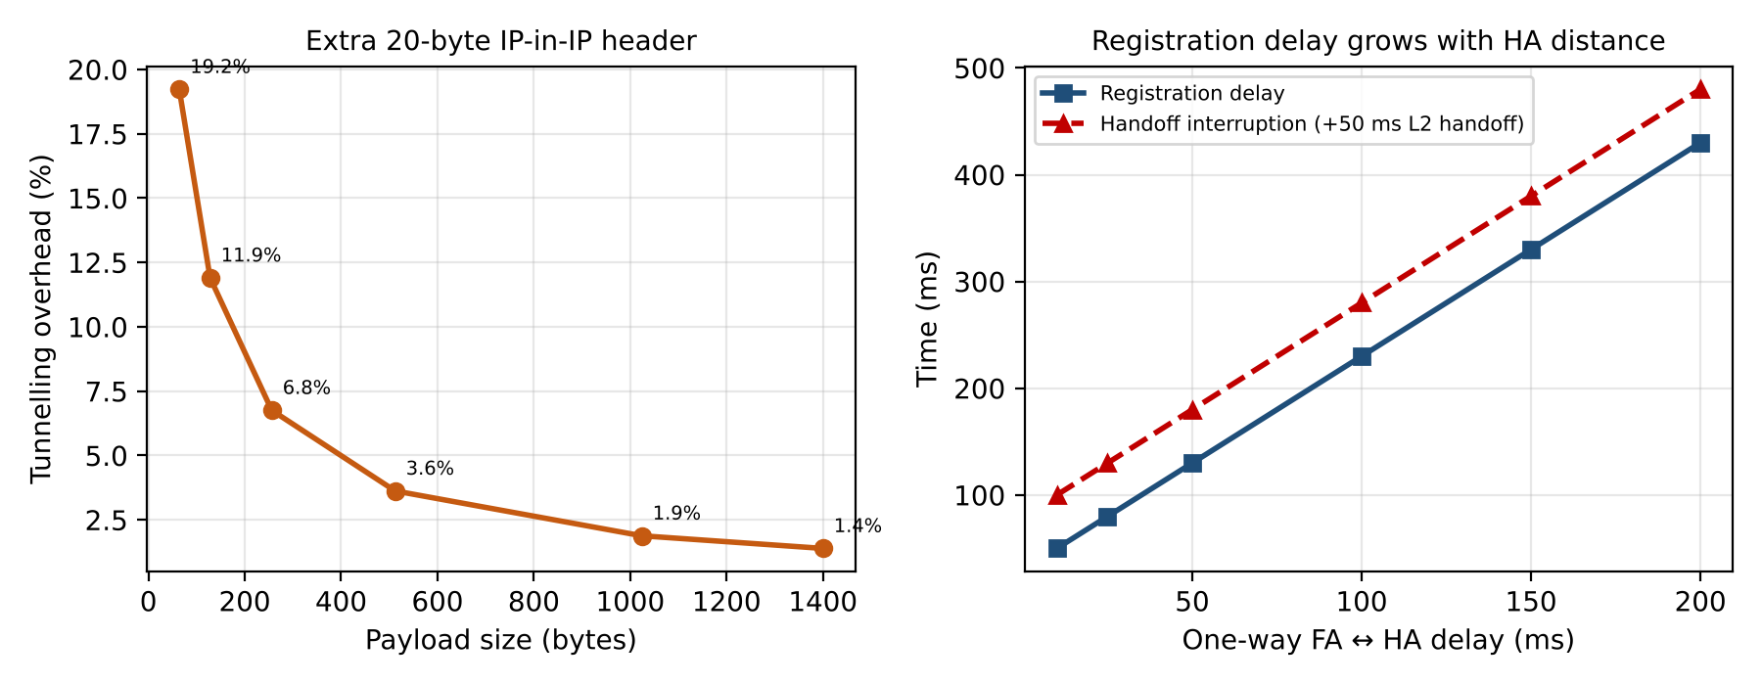
Figure 6: Tunnelling overhead versus payload size (left) and registration delay versus FA–HA delay (right); analytical values
Table 11: Mobile IP challenges
Challenge | Cause and quantified effect | Mitigation
Registration delay | Registration needs a round trip MN–FA–HA–FA–MN. With 10 ms wireless hops, 40 ms FA↔HA one-way and 10 ms HA processing: 2 × (10 + 40) + 10 = 110 ms. With a 270 ms satellite path it grows to ≈ 570 ms. | Regional (hierarchical) registration, a nearer HA, fast handoff.
Tunnelling overhead | Extra 20-byte header per packet: 8.3% on a 200-byte payload (40-byte IP/UDP header assumed), 1.4% on a 1400-byte payload. | Minimal encapsulation (8–12 bytes), header compression, co-located CoA with route optimisation.
Triangular routing | Forward packets detour through the HA. With CN→HA 30 ms, HA→FA 40 ms, FA→MN 10 ms the delay is 80 ms; a direct path would be about 45 ms. | Route optimisation (binding cache at CN), reverse tunnelling for symmetry.
Packet loss during mobility | Packets sent to the old FA between leaving and registering are lost: about 180 ms interruption (50 ms L2 + 20 ms discovery + 110 ms registration) ⇒ 9 packets at 50 packets/s. | Buffering and forwarding from the previous FA (smooth handoff), make-before-break handoff.
Security | Fake registrations could redirect a user's traffic (session hijack); replayed messages; tunnels can be spoofed. Ingress filtering may drop MN's packets with a home source address. | Authenticated registration (shared key, timestamps/nonces), IPsec on the tunnel, reverse tunnelling.
Scalability | Every MN needs a binding and each registration reaches the HA. The HA becomes a bottleneck and single point of failure with many mobile nodes. | Multiple/redundant HAs, hierarchical Mobile IP, binding lifetime tuning.

Joint design question – frequent change of network during a session
Problems that occur if a mobile user changes network very often during an active session:
- Registration storm: every move triggers a registration to a possibly distant HA, adding 110 ms or more each time and loading the HA.
- Repeated packet loss and reordering: each handoff loses about 9 packets (at 50 packets/s) and packets can arrive out of order.
- Transport-layer problems: TCP may treat the loss as congestion, time out and restart slowly, reducing throughput.
- Rising overhead and delay: tunnelling and the detour through the HA are paid on every packet.
- Stale bindings: packets keep going to an old CoA until the new binding is confirmed.
How these problems can be reduced:
- Hierarchical / regional registration: register locally at a regional agent for movements inside a region and contact the HA only when the region changes.
- Fast / smooth handoff: the old FA buffers and forwards packets to the new CoA for a short time (bi-casting), removing most of the loss.
- Route optimisation: the CN learns the CoA and sends directly, removing triangular routing.
- Co-located CoA and lower lifetime handling: avoid depending on an FA and tune binding lifetimes to the movement pattern.
- Stronger transport behaviour: use link-layer hints to stop TCP from reacting to handoff loss.

Q3 – Cellular Networks versus Ad Hoc Wireless Networks

Shared group work (Pramith and Preethika)
A cellular network divides an area into cells, each served by a fixed base station connected to a core network. An ad hoc network has no fixed infrastructure: mobile nodes talk directly when in range and forward packets for each other over several hops.
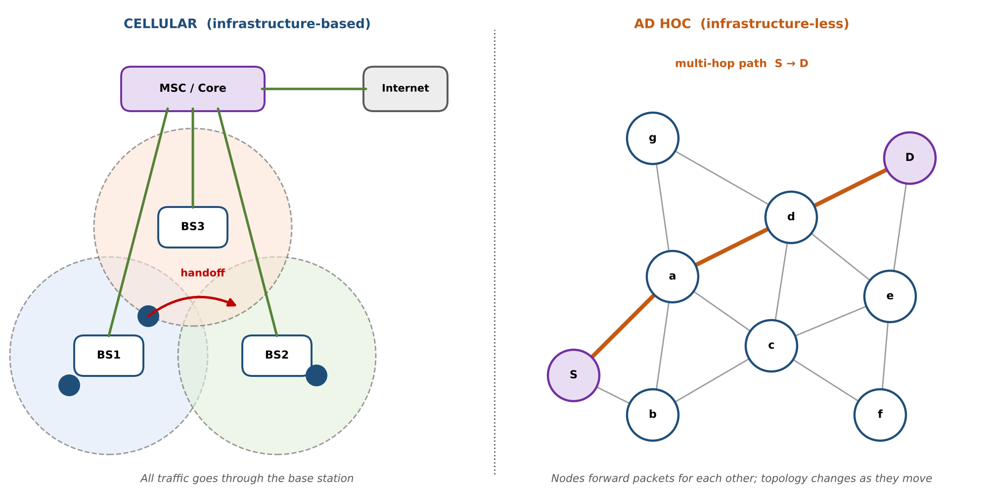
Figure 7: Cellular (infrastructure-based) and ad hoc (infrastructure-less) architectures

Student A – Pramith M: Cellular network investigation
- Architecture: mobile stations ↔ base stations (one per cell) ↔ mobile switching centre / core network ↔ Internet or telephone network (Figure 7, left).
- Role of base stations and infrastructure: the base station manages radio resources, authenticates users and relays all traffic; the core network handles routing, location management and billing.
- Centralised communication: even two phones in the same cell communicate through the base station; control is central and predictable.
- Handoff between cells: when a user leaves a cell, the network transfers the call to the next base station (hard or soft handoff) so the connection continues with only a short interruption.
- Scalability and coverage: frequency reuse lets capacity grow by adding cells; cell size is reduced in dense areas. Coverage depends on the number and placement of base stations.
- Suitable applications: mobile telephony, mobile broadband, video streaming, mobile payments and normal day-to-day internet access.

Student B – Preethika N: Ad hoc network investigation
- Architecture: a set of mobile nodes, each acting as host and router, connected by wireless links wherever two nodes are in radio range (Figure 7, right).
- Communication between mobile nodes: nodes in range communicate directly; otherwise the packet is forwarded by intermediate nodes.
- Dynamic topology: because nodes move, links appear and disappear, so routes must be discovered and repaired continuously.
- Multi-hop communication: a path such as S → a → d → D lets nodes reach destinations beyond their own radio range.
- Absence of fixed infrastructure: no base station, no central control; the network can be set up quickly anywhere.
- Suitable applications: disaster recovery and rescue, military operations, vehicle-to-vehicle networks, sensor networks, temporary meetings.
Table 12: Comparison of cellular and ad hoc networks
Parameter | Cellular network | Ad hoc network
Infrastructure | Fixed base stations, switching centres and a core network. | None; nodes form the network themselves.
Communication | Centralised, always through the base station. | Distributed, direct or multi-hop between nodes.
Routing | Simple for the user; routing handled in the fixed core network. | Every node routes; needs protocols such as DSDV or AODV.
Mobility | Supported with managed handoff between cells. | Free movement, but every move can change the topology.
Topology | Static star-like (cells) with a fixed backbone. | Dynamic, changes continuously.
Scalability | High: add cells and reuse frequencies. | Limited: overhead and delay grow with nodes and hops.
Handoff | Network-controlled between base stations. | No handoff; routes are rebuilt when links break.
Failure handling | Base-station or backhaul failure disconnects the whole cell. | Node failure only breaks routes through it; other paths are found.
Applications | Mobile phones, broadband, IoT with coverage. | Disaster areas, military, vehicle networks, temporary networks.

Joint engineering decision – disaster environment
Selected architecture: ad hoc (multi-hop) network, ideally with one or more gateway nodes if a backhaul link is available. Reasons: (1) cellular networks depend on towers, power and backhaul, which may be destroyed; (2) an ad hoc network can be deployed in minutes with the equipment the rescuers already carry; (3) there is no single point of failure, so communication continues while some nodes fail. The price is lower capacity and higher routing overhead, which is acceptable for short critical messages.
Cross-defence. Cellular networks depend on infrastructure because every call is controlled, routed and authenticated by the base station and core network; if the tower or its backhaul fails, devices in that cell have no path at all. Ad hoc networks continue without infrastructure because each node forwards for its neighbours, so as long as a chain of nodes within radio range exists, a route can be found.

Q4 – Applications of Mobile IP and Routing Requirements

Shared group work (Pramith and Preethika)
Selected application: mobile healthcare (ambulance telemedicine). An ambulance carries a patient from an accident site to a hospital. On the way it moves between many cellular and Wi-Fi networks, yet the paramedic must send vital signs and live video to a hospital specialist and receive instructions without the session dropping.
- Mobile entities: the ambulance gateway (MN) and the patient sensors connected to it.
- Fixed entities: hospital gateway (Home Agent), specialist doctor (CN), EHR and video server.
- Communication requirements: continuous real-time vitals, bidirectional video/voice, reliable delivery of patient records, secure transfer of private medical data.
- Applying Mobile IP: the ambulance keeps a permanent home address registered at the hospital HA; as it moves, it obtains a new CoA in each network and re-registers, so the doctor's session continues unchanged.
- Routing requirements created by mobility: the network must locate the ambulance (binding at the HA), forward packets to the current CoA, update routes after each handoff and keep the delay low enough for real-time video.

Student B – Preethika N: Application architecture
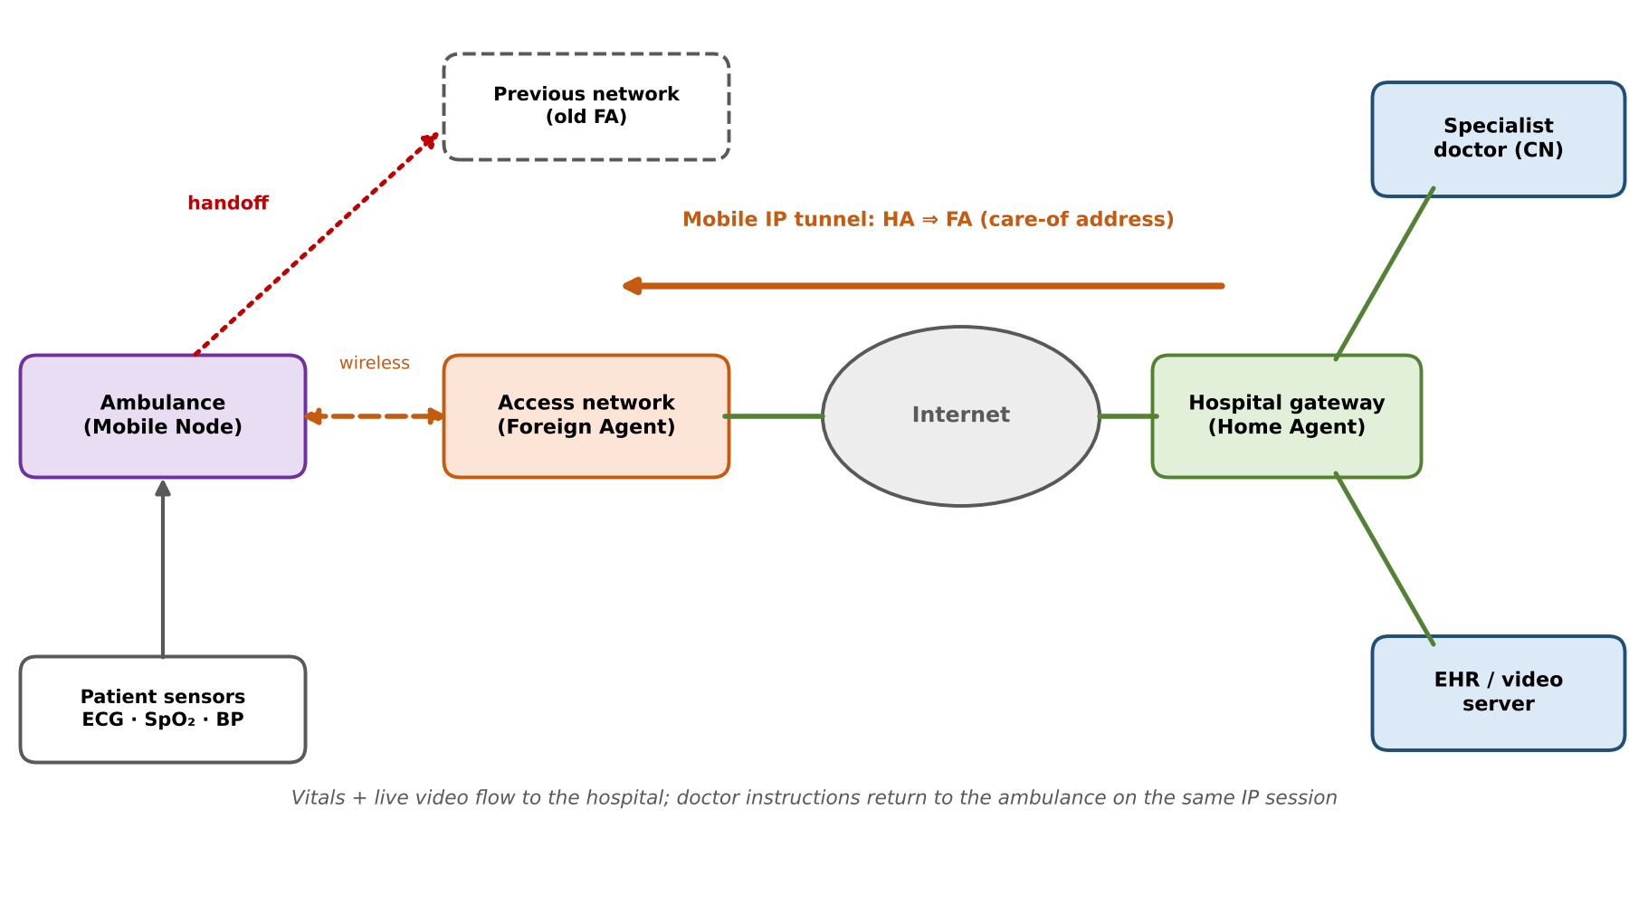
Figure 8: Mobile healthcare architecture using Mobile IP
Table 13: Required network components
Network component | Function in the application
Patient sensors (ECG, SpO₂, BP) | Generate vitals; connected to the ambulance gateway over a local link.
Ambulance gateway – Mobile Node | Aggregates data, holds the permanent home address, performs registration after each movement.
Access networks with Foreign Agent | Cellular/Wi-Fi networks along the route that provide the care-of address.
Hospital gateway – Home Agent | Keeps the binding, tunnels packets to the ambulance's current CoA.
Specialist doctor – Correspondent Node | Communicates with the ambulance using only its home address.
EHR / video server | Stores patient records and supports the video consultation.

Communication flow: (1) sensors send vitals to the ambulance gateway; (2) the gateway sends them to the hospital with source = home address; (3) when the ambulance enters a new network it registers a new CoA with the HA; (4) the doctor's messages to the home address are intercepted by the HA, tunnelled to the new CoA and delivered to the gateway; (5) the session continues without changing addresses. How Mobile IP supports mobility: the home address stays constant for the doctor and applications, while the CoA changes underneath.

Student A – Pramith M: Performance and requirement analysis
Table 14: Communication delay estimate (assumed values)
Delay component (one-way, doctor → ambulance) | Estimate (ms)
Hospital LAN to HA | 3
HA processing and encapsulation | 2
Internet path HA → access network | 35
FA decapsulation and forwarding | 2
Wireless access hop | 10
Total | ≈ 52

- Communication delay: about 52 ms one-way is well under the 150 ms limit for interactive voice/video, so the steady-state delay is acceptable.
- Packet delivery and connectivity: vitals need near-lossless delivery. This requires acknowledgements/retransmission and, where coverage is weak, a second interface (cellular + Wi-Fi) for redundancy.
- Interruption during movement: each handoff takes ≈ 180 ms (50 ms L2 + 20 ms discovery + 110 ms registration), losing about 9 packets at 50 packets/s. This is acceptable for vitals with buffering but visible as a short freeze in video.
- Mobility requirements: seamless handoff (< 200 ms), fast registration, a stable home address, and buffering at the FA during handoff.
- Security and reliability requirements: authenticated registration, IPsec/TLS encryption of patient data, redundant HAs and link failover.
Evaluation of Mobile IP suitability: Mobile IP is suitable for ambulance telemedicine because the user moves across different networks and needs the same IP session. Its weak points are handoff interruption, tunnelling overhead and security, which can be reduced with fast handoff, route optimisation and IPsec. For regions with no infrastructure, it should be combined with an ad hoc network (Q7).

Q5 – Proactive Routing Protocols in Mobile Networks

Shared group work (Pramith and Preethika)
Proactive (table-driven) routing protocols keep a route to every destination in each node's routing table at all times, by exchanging routing updates continuously. A packet can be sent immediately because the route already exists. We selected DSDV (Destination-Sequenced Distance-Vector), a proactive protocol designed for mobile ad hoc networks.

Student A – Pramith M: Protocol design
Principle of proactive routing: every node periodically advertises its routing table to its neighbours and sends a triggered update when something changes. Hence each node has up-to-date routes to all other nodes, at the price of constant control traffic.
DSDV operation. DSDV is based on the distance-vector (Bellman-Ford) algorithm. Each routing table entry has: destination, next hop, metric (hop count) and sequence number. Updates are of two kinds: a full dump (entire table, sent periodically) and incremental updates (only changed entries, sent when the topology changes).
Sequence numbers and route updates. Each destination originates an even sequence number that it increases with every advertisement. A route with a higher sequence number is always preferred; if sequence numbers are equal, the lower metric wins. When a link breaks, the node that detects it advertises the route with metric ∞ and an odd sequence number (old number + 1). A new even number from the destination later replaces it. Sequence numbers prevent routing loops and stale routes.
Routing table maintenance: (1) periodic full dump (every 15 s in our model); (2) incremental update after each topology change; (3) a node replaces a route only if the new one has a newer sequence number or a better metric; (4) a settling-time delay avoids advertising unstable routes.
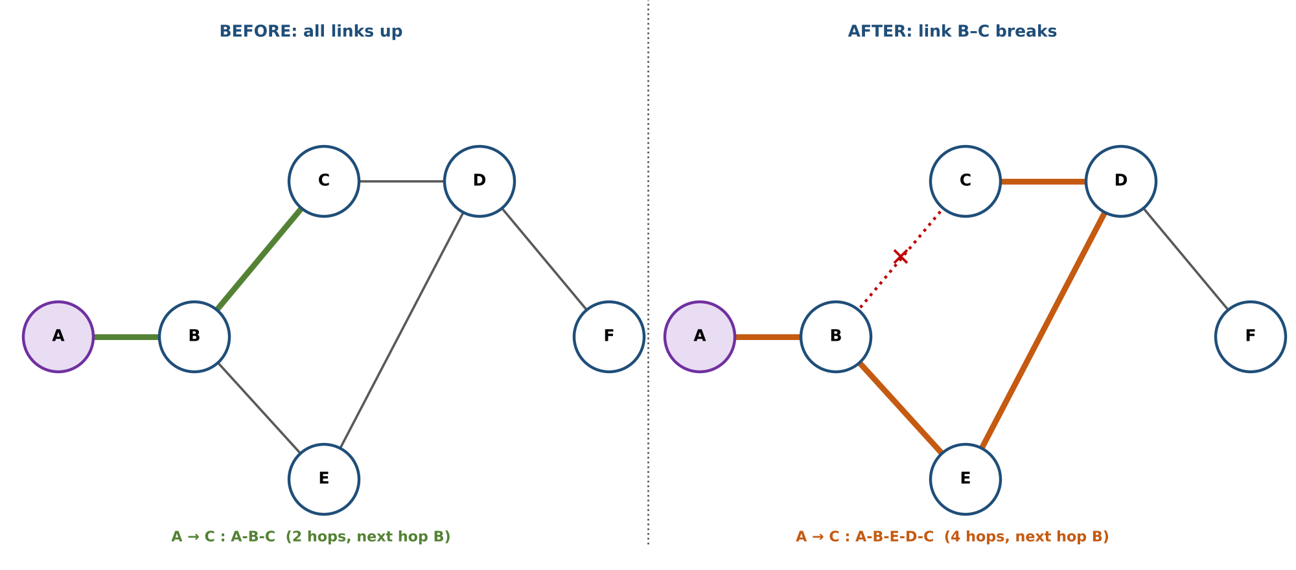
Figure 9: Sample topology before and after the link B–C breaks (A is the observed node)
Table 15: Routing table of node A BEFORE the topology change
Destination | Next hop | Metric | Seq. no.
A | A | 0 | 206
B | B | 1 | 134
C | B | 2 | 156
D | B | 3 | 210
E | B | 2 | 178
F | B | 4 | 322

Table 16: Routing table of node A just after B–C breaks (triggered update from B)
Destination | Next hop | Metric | Seq. no.
A | A | 0 | 206
B | B | 1 | 134
C | B | ∞ | 157 (odd = broken)
D | B | 3 | 210
E | B | 2 | 178
F | B | 4 | 322

Table 17: Routing table of node A AFTER convergence (new route A-B-E-D-C)
Destination | Next hop | Metric | Seq. no.
A | A | 0 | 206
B | B | 1 | 134
C | B | 4 | 158 (new, from C)
D | B | 3 | 210
E | B | 2 | 178
F | B | 4 | 322

The change in Tables 15 to 17 is exactly the DSDV rule: B detects the break and advertises C with ∞ and odd sequence number 157; C then advertises itself with the newer even number 158 through D and E; A accepts the route because 158 > 157 and its metric is now 4.

Student B – Preethika N: Performance investigation
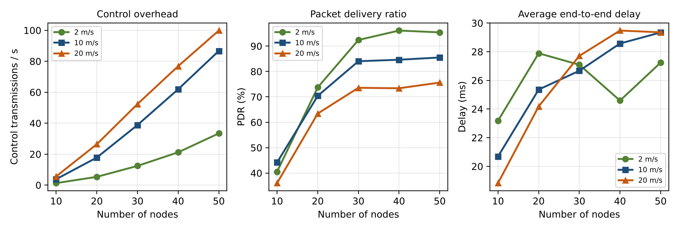
Figure 10: DSDV control overhead, delivery ratio and delay versus network size (simulation, 3 node speeds)
Table 18: DSDV behaviour for different network sizes (10 m/s, simulation)
Nodes | Avg. network diameter (hops) | Control transmissions / s | Packet delivery (%) | Avg delay (ms)
10 | 3.6 | 3.8 | 44.2 | 20.7
20 | 5.7 | 17.8 | 70.4 | 25.4
30 | 5.8 | 38.8 | 84.0 | 26.7
40 | 5.8 | 61.9 | 84.6 | 28.6
50 | 5.8 | 86.7 | 85.5 | 29.3

- Routing-control overhead: grows quickly with network size. Each periodic dump carries one entry per node and every node sends one, so the load is roughly proportional to N². In the simulation it rises from 3.8 to 86.7 control transmissions per second between 10 and 50 nodes, and it also rises with speed (Figure 10, left).
- Route availability: routes are always present in the table, but they can be stale for the update delay. At 20 m/s delivery is lower than at 2 m/s because packets follow routes that have just broken.
- Convergence behaviour: after a link break the triggered updates must travel across the network (about the network diameter, 5.8 hops at 30 nodes), so convergence time grows with network size and link-change rate.
- Control-message transmission: periodic full dumps (all nodes) + incremental updates (only changed entries). Triggered updates keep response fast but increase load when mobility is high.
- Delay and delivery: end-to-end delay is low (26.7 ms at 30 nodes) because no discovery is needed; delivery is 84.0% at 30 nodes and falls when mobility is high or the network is partitioned (only 44.2% at 10 nodes, because many source-destination pairs are not connected at all).

Q6 – Reactive Routing and Protocol Comparison

Student A – Pramith M: Reactive routing investigation
Reactive (on-demand) routing finds a route only when a node has data to send. No routes are kept for unused destinations, so little control traffic is generated when the network is idle. AODV (Ad hoc On-demand Distance Vector) is the most widely used reactive protocol.
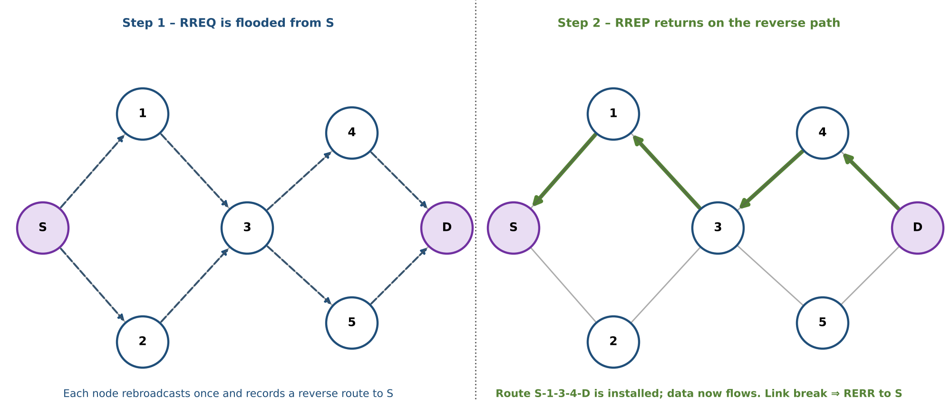
Figure 11: AODV route discovery: RREQ flood (left) and RREP along the reverse path (right)
Table 19: AODV control messages
Message | Purpose and operation
RREQ (Route Request) | Broadcast by the source when it needs a route. Contains source and destination addresses, source and destination sequence numbers, broadcast ID and hop count. Each node rebroadcasts it once (duplicates are discarded) and creates a reverse route to the source.
RREP (Route Reply) | Sent unicast by the destination (or an intermediate node with a fresh enough route) back along the reverse path. Each node on the way installs the forward route, so the source can start sending.
RERR (Route Error) | Sent when a node detects a broken link (missed HELLO or failed transmission). It lists the unreachable destinations and travels back to all affected sources, which delete the route and rediscover it when needed.

Route discovery follows Figure 11: the source floods an RREQ, the destination answers with an RREP, and the data flow starts. Route maintenance: nodes on active routes send periodic HELLO messages; when a link fails, an RERR is generated; the source starts a new discovery (or the node may try a local repair). Unused routes expire after a timeout.
Effect of mobility on route discovery. The more nodes move, the more active links break, so more RERRs and new discoveries are needed. Each discovery floods the network, so the cost grows with mobility. In the simulation (30 nodes) AODV control traffic rises from 73.0 to 132.2 transmissions per second when speed increases from 1 to 30 m/s, and delay rises from 45.0 to 55.7 ms because more packets have to wait for a new route.

Student B – Preethika N: Comparative verification of AODV and DSDV
Table 20: DSDV versus AODV
Aspect | DSDV (proactive) | AODV (reactive)
Route discovery | No discovery; routes exist already from periodic and triggered updates. | On demand: RREQ flood and RREP when a route is needed.
Routing table | Entry for every destination (N entries per node), with sequence numbers. | Entries only for destinations in use (and reverse routes), with timeouts.
Control overhead | Continuous; grows with N and with topology changes even without traffic. | Depends on traffic and mobility: floods per discovery, RERR on breaks, HELLO from active nodes.
Initial delay | Lowest: first packet is sent immediately. | Higher: the first packet waits for RREQ/RREP (≈ 2 × hops × per-hop delay).
Mobility handling | Updates spread by triggered messages; routes can be stale until they converge. | Broken routes are repaired only when needed; RERR informs sources quickly.
Suitable scenarios | Small, fairly stable networks with many active flows and strict delay needs. | Large or highly mobile networks with few active flows and limited bandwidth.

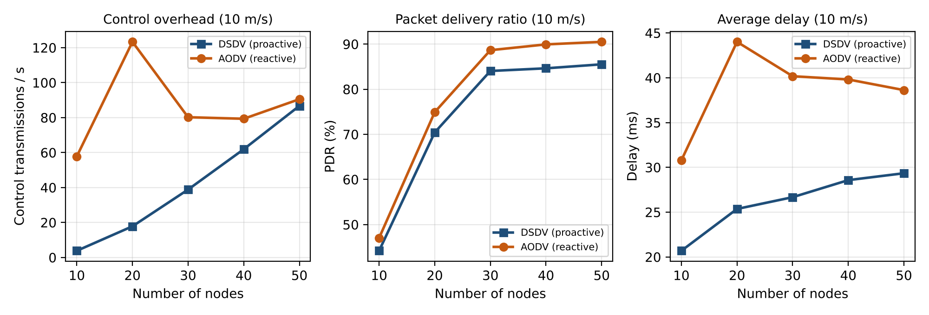
Figure 12: DSDV versus AODV for different network sizes at 10 m/s (simulation)
Table 21: DSDV and AODV for different numbers of nodes (10 m/s, simulation)
Nodes | DSDV ctrl/s | AODV ctrl/s | DSDV PDR % | AODV PDR % | DSDV delay ms | AODV delay ms
10 | 3.8 | 57.8 | 44.2 | 47.0 | 20.7 | 30.8
20 | 17.8 | 123.3 | 70.4 | 74.9 | 25.4 | 44.0
30 | 38.8 | 80.2 | 84.0 | 88.7 | 26.7 | 40.2
40 | 61.9 | 79.3 | 84.6 | 89.9 | 28.6 | 39.8
50 | 86.7 | 90.5 | 85.5 | 90.5 | 29.3 | 38.6

Reading the results. AODV has a higher delivery ratio (88.7% vs 84.0% at 30 nodes) because it repairs a broken route as soon as it is needed, while DSDV may use a stale route for about a second. AODV has a higher delay (40.2 ms vs 26.7 ms) because of route discovery. Overhead: DSDV overhead grows steadily with N (3.8 to 86.7 transmissions/s), while AODV stays roughly constant for N ≥ 30 (about 80.2 to 90.5); the two become comparable at 50 nodes, and DSDV would be more expensive for larger networks. At small N, AODV overhead is high in our model because many destinations are unreachable and the model repeats failed discoveries without rate limiting.

Joint question – highly dynamic network with frequent topology changes
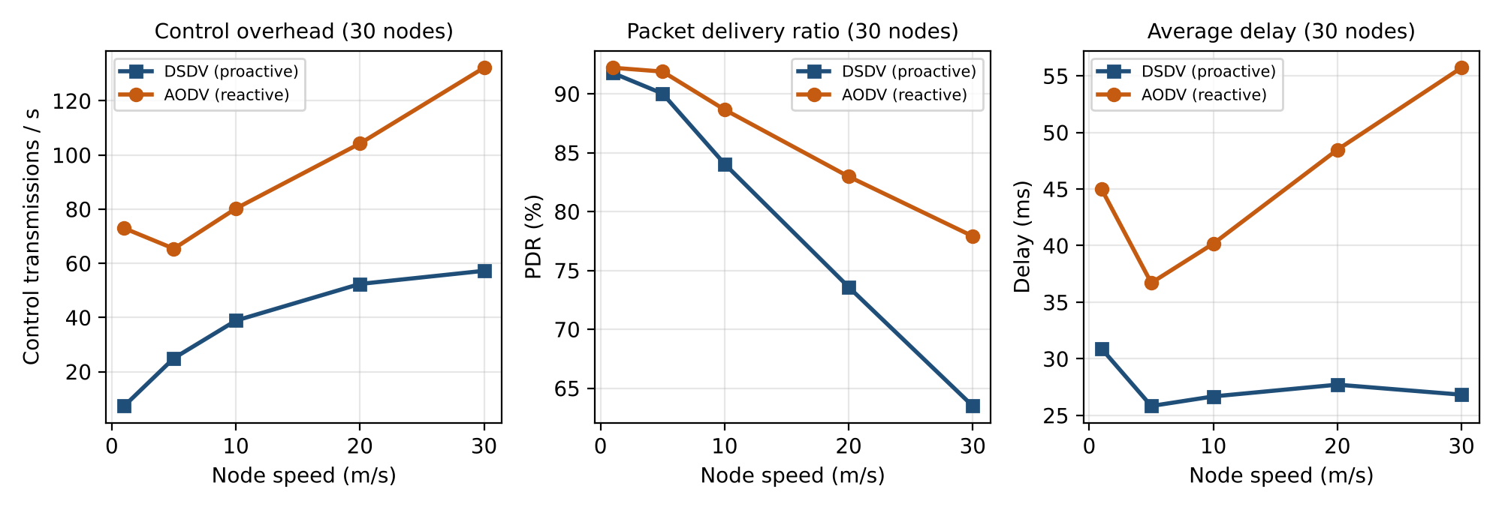
Figure 13: DSDV versus AODV for increasing node speed, 30 nodes (simulation)
Table 22: DSDV and AODV for increasing mobility (30 nodes, simulation)
Speed (m/s) | DSDV ctrl/s | AODV ctrl/s | DSDV PDR % | AODV PDR % | DSDV delay ms | AODV delay ms
1 | 7.3 | 73.0 | 91.8 | 92.2 | 30.9 | 45.0
5 | 24.9 | 65.4 | 90.0 | 91.9 | 25.8 | 36.7
10 | 38.8 | 80.2 | 84.0 | 88.7 | 26.7 | 40.2
20 | 52.4 | 104.2 | 73.6 | 83.0 | 27.7 | 48.5
30 | 57.2 | 132.2 | 63.5 | 77.9 | 26.8 | 55.7

Decision: AODV. (1) Mobility: at 30 m/s DSDV delivers only 63.5% of packets against 77.9% for AODV, because DSDV tables are always slightly out of date when links change every few seconds. (2) Routing overhead: DSDV overhead rises with mobility (7.3 to 57.2 transmissions/s) as triggered updates multiply and it grows with network size; AODV overhead also rises (73.0 to 132.2), and in our model it is higher than DSDV for this size, but it is spent only on routes that are really in use, so it does not scale with the number of destinations. (3) Delay: AODV pays route-discovery delay (55.7 ms vs 26.8 ms), which is acceptable because lost packets are worse than a few tens of milliseconds for delay. We therefore choose AODV for a highly dynamic network, accepting higher control traffic and initial delay; DSDV is better only if the network is small, nearly static and needs minimum delay.

Q7 – Design a Mobile Emergency Communication Network
Scenario. During a natural disaster, ambulances, police vehicles, rescue teams and medical personnel move continuously across different areas. Fixed infrastructure may be unavailable, while critical information must be exchanged with minimum delay.

Stage 1 – Independent design proposals (retained as submitted)

Student A – Pramith M: Architecture and mobility management proposal
- Wireless architecture: a hybrid network. Responders form a multi-hop wireless mesh; one or more gateway vehicles carry a long-range radio and a satellite/microwave backhaul to the Command Centre. Drones can act as relays.
- Mobility management strategy: each responder keeps a permanent home address in the Command Centre network. As it moves between gateway coverage areas, it registers a new care-of address.
- Role of Mobile IP: gives each responder a stable address so that sessions with the Command Centre (voice, location reports, medical records) survive changes of gateway. The Command Centre router is the Home Agent; gateway vehicles act as Foreign Agents.
- Communication model: (1) responder ↔ Command Centre through the gateway with Mobile IP; (2) responder ↔ responder directly through the mesh for local coordination.

Student B – Preethika N: Routing and failure-handling proposal
- Routing strategy: on-demand (reactive) routing, because nodes move continuously and only a few flows are active at a time.
- Protocol selection: AODV for the mobile mesh. DSDV is considered only inside small, static groups.
- Route maintenance: HELLO messages on active routes, RERR on link failure, local repair at the node that detects the break, route expiry for unused routes.
- Failure handling: on node or link failure the source rediscovers a route through other nodes; packets to unreachable destinations are buffered briefly and then reported; messages are retried and acknowledged.
- Performance parameters: end-to-end delay, packet delivery ratio, routing control overhead, route-discovery time, and number of route breaks.

Stage 2 – Comparison of the two designs
Table 23: Comparison of the independent designs
Aspect | Pramith's design (architecture, Mobile IP) | Preethika's design (routing) | Conclusion
Agreement | Mobile, infrastructure-independent network with gateways. | Reactive multi-hop routing for mobile nodes. | Both need an ad hoc mesh, not a cellular-only network.
Difference | Focuses on addressing and session continuity (Mobile IP). | Focuses on routing inside the mesh and failure handling. | The designs are complementary: one handles addresses, the other paths.
Strengths | Stable address, connection to Command Centre, gateway redundancy. | Low idle overhead, fast repair, no dependence on infrastructure. | Combine both.
Weaknesses | Registration delay and tunnelling overhead; depends on the backhaul; needs a fallback when no gateway exists. | Discovery delay for the first packet; flooding cost grows with mobility; does not give a stable address. | Use Mobile IP only for Command Centre traffic; keep local traffic on AODV.
Mobile IP requirement | Required for sessions with the Command Centre. | Not mentioned. | Mobile IP required for Command-Centre sessions only.
Expected overhead | Registration (≈ 5 messages/handoff) and 20-byte tunnel header. | RREQ floods, RERR and HELLO. | Both small compared with the traffic when moderate.
Expected delay | Registration ≈ 110 ms plus tunnel path. | Discovery ≈ 2 × hops × 10 ms. | Few hundred ms worst case.
Node mobility | Handled by re-registration. | Handled by route repair. | Re-registration + route repair together.

Stage 3 – Joint final design

Shared work (Pramith and Preethika)
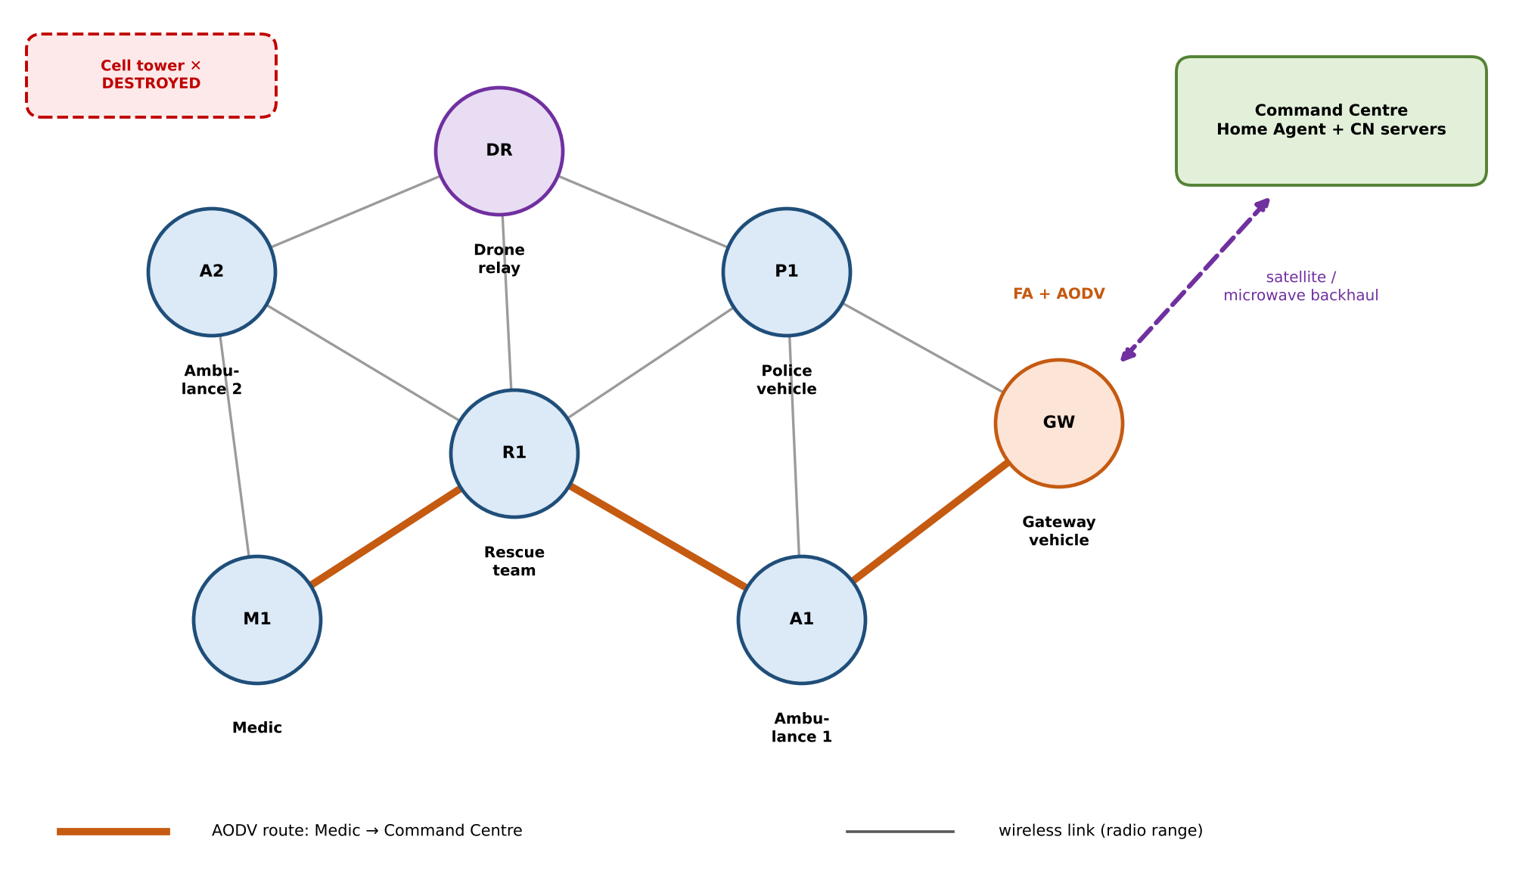
Figure 14: Final design: ad hoc mesh of emergency responders with a gateway to the Command Centre
Table 24: Final network design
Part of the design | Final decision
Network architecture | Multi-hop wireless mesh of mobile nodes (ambulances, police, rescue teams, medics) plus drone relays. Gateway vehicles link the mesh to the Command Centre by satellite/microwave. No fixed infrastructure is needed inside the mesh.
Mobile IP components | Mobile Node: every responder device, permanent home address from the Command Centre network.  Home Agent: router at the Command Centre.  Foreign Agent: gateway vehicle in the current area (provides the care-of address).  Correspondent Node: Command Centre servers (dispatch, medical records) and other peers.
Registration and tunnelling | On entering a gateway's area, the MN receives its agent advertisement, registers through it (Figure 5) and the HA stores home address → gateway CoA. Command Centre packets are tunnelled to the gateway, which delivers them over the mesh. If no gateway is reachable, the MN keeps working inside the mesh and registers again when a gateway appears.
Routing protocol | AODV inside the mesh. Reasons: high mobility, few simultaneous flows, low idle overhead, fast repair of broken routes (Q6: higher delivery than DSDV when mobility is high).
Local traffic | Responder-to-responder messages use AODV routes directly and do not go through the HA, which avoids triangular routing for local coordination.
Failure handling | Node failure: neighbours detect missing HELLOs, send RERR; sources rediscover a path through other nodes.  Link failure: local repair or new RREQ; buffer packets briefly during repair.  Network disconnection: nodes keep communicating within their partition; messages for the Command Centre are queued and sent when a gateway becomes reachable; a drone relay can be launched to reconnect partitions.

Stage 4 – Validation

Student A – Pramith M: Analytical validation
Table 25: Analytical validation of Mobile IP
Quantity | Calculation (assumed values) | Result
Registration delay (microwave backhaul) | 2 × (10 ms wireless + 40 ms FA↔HA) + 10 ms processing | 110 ms
Registration delay (satellite backhaul) | 2 × (10 + 270) + 10 | 570 ms
Handoff interruption (microwave) | 50 ms L2 + 20 ms discovery + 110 ms registration | 180 ms
Handoff interruption (satellite) | 50 + 20 + 570 | 640 ms
Packets lost per handoff at 50 packets/s | 0.180 s × 50 and 0.640 s × 50 | 9 and 32
Tunnel overhead (200-byte payload) | 20 / (200 + 40) | 8.3%
Extra forward delay of triangular routing | 80 ms via HA − 45 ms direct (for Command Centre traffic CN and HA are co-located, so ≈ 0) | ≈ 0 ms for Command Centre; 35 ms for peer traffic if it went via the HA

- Mobile IP overhead: small (8.3% header and 5 signalling messages per handoff) and only applied to Command-Centre traffic.
- Mobility-related delay and interruption: 180 ms per handoff with a microwave backhaul. A vehicle changing gateway every 30 s loses about 0.6% of its time to handoff, which is acceptable. With satellite the interruption is 640 ms, so buffering at the gateway and regional registration are needed.
- Packet delivery: about 9 packets are lost per handoff without buffering; forwarding from the previous gateway removes most of this.
- Justification of the mobility mechanism: Mobile IP is chosen because the Command Centre sessions must survive gateway changes without being reset; the cost is moderate compared with the benefit.

Student B – Preethika N: Experimental validation
Test cases were run in the routing simulation (Section "Simulation Set-up and Assumptions"). Each result is the average of 5 runs.
Table 26: Test cases and recorded results (simulation)
Test | Condition | DSDV: PDR % / delay ms / ctrl per s | AODV: PDR % / delay ms / ctrl per s
TC1 | 10 nodes, 10 m/s (sparse) | 44.2 / 20.7 / 3.8 | 47.0 / 30.8 / 57.8
TC2 | 20 nodes, 10 m/s | 70.4 / 25.4 / 17.8 | 74.9 / 44.0 / 123.3
TC3 | 30 nodes, 10 m/s | 84.0 / 26.7 / 38.8 | 88.7 / 40.2 / 80.2
TC4 | 50 nodes, 10 m/s (dense) | 85.5 / 29.3 / 86.7 | 90.5 / 38.6 / 90.5
TC5 | 30 nodes, 1 m/s (slow) | 91.8 / 30.9 / 7.3 | 92.2 / 45.0 / 73.0
TC6 | 30 nodes, 5 m/s | 90.0 / 25.8 / 24.9 | 91.9 / 36.7 / 65.4
TC7 | 30 nodes, 20 m/s (fast) | 73.6 / 27.7 / 52.4 | 83.0 / 48.5 / 104.2
TC8 | 30 nodes, 30 m/s (very fast) | 63.5 / 26.8 / 57.2 | 77.9 / 55.7 / 132.2
TC9 | 30 nodes, 10 m/s, 20% of nodes fail at t = 75 s (PDR after failure) | 81.0 (no failure: 82.5) | 85.4 (no failure: 87.9)
TC10 | Same, 40% of nodes fail (PDR after failure) | 72.7 | 76.9

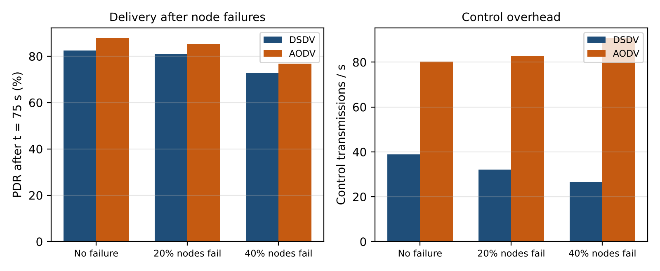
Figure 15: Node-failure tests: delivery after failure and control overhead (30 nodes, 10 m/s)
- Number of mobile nodes (TC1 to TC4): both protocols improve from 10 to 30 nodes because the network becomes connected; AODV has the higher delivery, DSDV the lower delay. DSDV overhead keeps growing with N (3.8 to 86.7).
- Mobility conditions (TC5 to TC8): DSDV delivery falls from 91.8% to 63.5% as speed rises, AODV from 92.2% to 77.9%. The gap between them widens with speed.
- Proactive vs reactive: DSDV is cheaper when mobility is low (7.3 vs 73.0 transmissions/s at 1 m/s) and has lower delay; AODV gives better delivery at high mobility.
- Node failure (TC9, TC10): after 20% of nodes fail, delivery drops only slightly (87.9% to 85.4% for AODV), because alternative paths exist. With 40% failures it falls to 76.9% as the network becomes sparse and partly disconnected.

Stage 5 – Cross-defence

Student A – Pramith M: Why is the selected routing protocol appropriate?
AODV suits the emergency network because responders move continuously and only a few communication flows are active at one time. AODV does not maintain routes to every node, so it avoids constant table exchanges in a network where topology changes every few seconds. When a link breaks it reports the error and rebuilds only the routes that are in use. In the experiments it kept the highest delivery ratio at high mobility (77.9% vs 63.5% at 30 m/s) and kept delivering after node failures. Its disadvantages (first-packet discovery delay and flooding cost) are acceptable for short critical messages.

Student B – Preethika N: How does Mobile IP maintain communication when a node changes location?
The mobile node keeps one permanent home address, so the Command Centre and all applications always use the same address. When the node moves into another gateway's area it learns a new care-of address from the agent advertisement and registers it with the Home Agent. The HA updates the binding (home address → new CoA). Packets sent to the home address are intercepted by the HA, tunnelled (IP-in-IP) to the current CoA and delivered by the foreign agent. As the address seen by the session never changes, the connection continues; only the packets sent during the short registration period (≈ 180 ms) are at risk, and buffering at the gateway can recover them.

Stage 6 – Joint evaluation

Shared work (Pramith and Preethika)
Table 27: Joint evaluation
Question | Answer
Why is the architecture suitable? | It does not rely on fixed infrastructure inside the disaster area, can be deployed quickly, has no single point of failure in the mesh, and still reaches the Command Centre through gateways.
Why is Mobile IP required? | For sessions between responders and the Command Centre that must survive changes of gateway without changing IP address. It is not needed for local traffic inside the mesh, which uses AODV directly.
Why is the selected routing protocol appropriate? | AODV handles high mobility with good delivery, has low idle overhead and repairs routes on demand (Tables 21 to 26).
What overhead is introduced? | Mobile IP: 5 signalling messages per handoff and 8.3% header overhead on tunnelled packets. AODV: RREQ floods, RERR and HELLO messages, about 80 to 130 transmissions per second for 30 nodes in the simulation.
How does mobility affect performance? | Faster movement means more route breaks and handoffs: delivery falls (AODV 92.2% → 77.9%), delay rises (45.0 → 55.7 ms) and control traffic increases.
What happens when connectivity is lost? | Nodes keep communicating inside their partition. Messages for the Command Centre are queued and sent after re-registration through a gateway; drone relays or a moved gateway can reconnect partitions.
When is the solution not appropriate? | Very large networks (flooding cost), extremely fast movement (> 30 m/s), hard real-time voice over many hops, long satellite backhaul without buffering (640 ms interruption), or very dense traffic where capacity is the limit. A cellular network is better when infrastructure is working.

Conclusion – what should a network designer analyse before selecting Mobile IP and a routing protocol for a highly mobile wireless environment?
- Mobility pattern: speed, how often nodes change network, and whether sessions must survive these changes (decides whether Mobile IP is needed).
- Infrastructure availability: whether base stations, gateways and a home network are present or have to be created.
- Network size and density: number of nodes and hops, because proactive overhead grows with size while reactive flooding cost grows with active flows.
- Traffic pattern: number of simultaneous flows and the tolerance to initial delay (decides proactive vs reactive).
- Performance targets: acceptable delay, delivery ratio and interruption time, including backhaul delay.
- Overhead budget: available bandwidth and battery for control messages and tunnelling.
- Failure and security requirements: node/link failure behaviour, authentication of registrations, and encryption.

Contribution Record
Table 28: Contribution record
Question | Student A – Pramith M (primary contribution) | Student B – Sai Preethika N (primary contribution) | Joint work
Q1 | Network architecture; analytical investigation of the mobility scenario | Mobility and performance analysis; mobility logic | Wireless network analysis; simulated scenario
Q2 | Mobile IP operation (roles, registration, tunnelling) | Mobile IP challenges | Mobile IP architecture; worked example; joint design question
Q3 | Cellular network | Ad hoc network | Comparative analysis; disaster decision
Q4 | Performance and requirement analysis | Application architecture | Application evaluation
Q5 | Protocol design (DSDV, tables before/after) | Performance investigation | Proactive routing
Q6 | Reactive routing (AODV) | DSDV–AODV comparison | Routing evaluation; joint question
Q7 | Architecture proposal; analytical validation | Routing proposal; experimental validation | Final network design; joint evaluation

Both students have studied the complete assignment and are prepared to answer questions on any part of the submitted work.
Pramith M (192372174) Sai Preethika N (192372344)

